SEC Form 3
FORM 3 | UNITED STATES SECURITIES AND EXCHANGE COMMISSION  Washington, D.C. 20549  INITIAL STATEMENT OF BENEFICIAL OWNERSHIP OF SECURITIES  Filed pursuant to Section 16(a) of the Securities Exchange Act of 1934  or Section 30(h) of the Investment Company Act of 1940
  OMB APPROVAL
  OMB Number: | 3235-0104
  Estimated average burden
  hours per response: | 0.5
1. Name and Address of Reporting Person*  (Street) | 2. Date of Event Requiring Statement (Month/Day/Year)  08/05/2026 | 3. Issuer Name and Ticker or Trading Symbol  BLACKBAUD INC [ BLKB ]  Foreign Trading Symbol
  BOOR ANTHONY W
  (Last) | (First) | (Middle)
  65 FAIRCHILD STREET
  CHARLESTON | SC | 29492
  (City) | (State) | (Zip)
 |  | 4. Relationship of Reporting Person(s) to Issuer  (Check all applicable) | 5. If Amendment, Date of Original Filed (Month/Day/Year)
   | Director |  | 10% Owner
   | Officer (give title below) |  | Other (specify below)
6. Individual or Joint/Group Filing (Check Applicable Line)
Form filed by One Reporting Person
Form filed by More than One Reporting Person

Table I - Non-Derivative Securities Beneficially Owned
1. Title of Security (Instr. 4) | 2. Amount of Securities Beneficially Owned (Instr. 4) | 3. Ownership Form: Direct (D) or Indirect (I) (Instr. 5) | 4. Nature of Indirect Beneficial Ownership (Instr. 5)
Common Stock | 91,789 | D
Table II - Derivative Securities Beneficially Owned
(e.g., puts, calls, warrants, options, convertible securities)
1. Title of Derivative Security (Instr. 4) | 2. Date Exercisable and Expiration Date (Month/Day/Year) |  | 3. Title and Amount of Securities Underlying Derivative Security (Instr. 4) |  | 4. Conversion or Exercise Price of Derivative Security | 5. Ownership Form: Direct (D) or Indirect (I) (Instr. 5) | 6. Nature of Indirect Beneficial Ownership (Instr. 5)
1. Title of Derivative Security (Instr. 4) | Date Exercisable | Expiration Date | Title | Amount or Number of Shares | 4. Conversion or Exercise Price of Derivative Security | 5. Ownership Form: Direct (D) or Indirect (I) (Instr. 5) | 6. Nature of Indirect Beneficial Ownership (Instr. 5)
Explanation of Responses:
Remarks:
See Exhibit 99.1.
 | /s/ S. Halle Vakani, Attorney-in-Fact | 08/17/2026
 | ** Signature of Reporting Person | Date
Reminder: Report on a separate line for each class of securities beneficially owned directly or indirectly.
* If the form is filed by more than one reporting person, see Instruction 5 (b)(v).
** Intentional misstatements or omissions of facts constitute Federal Criminal Violations See 18 U.S.C. 1001 and 15 U.S.C. 78ff(a).
Note: File three copies of this Form, one of which must be manually signed. If space is insufficient, see Instruction 6 for procedure.
Persons who respond to the collection of information contained in this form are not required to respond unless the form displays a currently valid OMB Number.
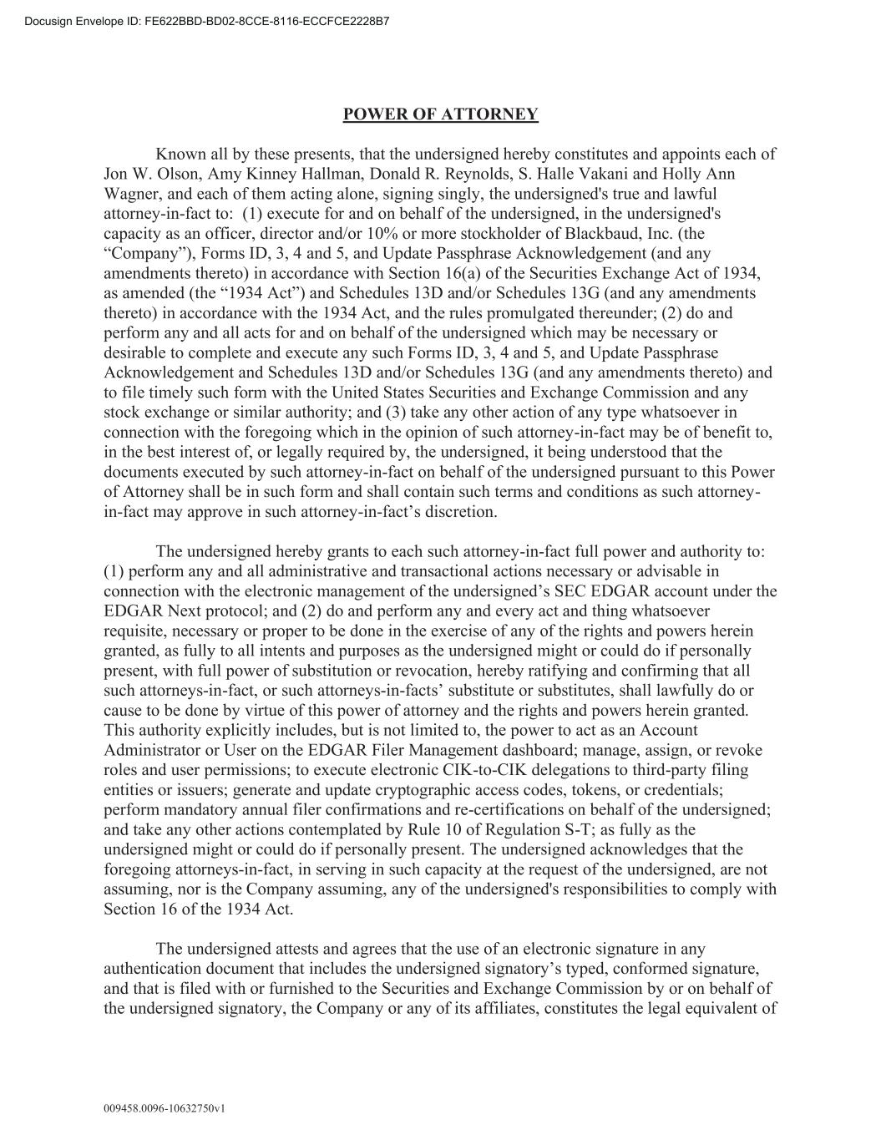
009458.0096-10632750v1 POWER OF ATTORNEY Known all by these presents, that the undersigned hereby constitutes and appoints each of Jon W. Olson, Amy Kinney Hallman, Donald R. Reynolds, S. Halle Vakani and Holly Ann Wagner, and each of them acting alone, signing singly, the undersigned's true and lawful attorney-in-fact to: (1) execute for and on behalf of the undersigned, in the undersigned's capacity as an officer, director and/or 10% or more stockholder of Blackbaud, Inc. (the “Company”), Forms ID, 3, 4 and 5, and Update Passphrase Acknowledgement (and any amendments thereto) in accordance with Section 16(a) of the Securities Exchange Act of 1934, as amended (the “1934 Act”) and Schedules 13D and/or Schedules 13G (and any amendments thereto) in accordance with the 1934 Act, and the rules promulgated thereunder; (2) do and perform any and all acts for and on behalf of the undersigned which may be necessary or desirable to complete and execute any such Forms ID, 3, 4 and 5, and Update Passphrase Acknowledgement and Schedules 13D and/or Schedules 13G (and any amendments thereto) and to file timely such form with the United States Securities and Exchange Commission and any stock exchange or similar authority; and (3) take any other action of any type whatsoever in connection with the foregoing which in the opinion of such attorney-in-fact may be of benefit to, in the best interest of, or legally required by, the undersigned, it being understood that the documents executed by such attorney-in-fact on behalf of the undersigned pursuant to this Power of Attorney shall be in such form and shall contain such terms and conditions as such attorney- in-fact may approve in such attorney-in-fact’s discretion. The undersigned hereby grants to each such attorney-in-fact full power and authority to: (1) perform any and all administrative and transactional actions necessary or advisable in connection with the electronic management of the undersigned’s SEC EDGAR account under the EDGAR Next protocol; and (2) do and perform any and every act and thing whatsoever requisite, necessary or proper to be done in the exercise of any of the rights and powers herein granted, as fully to all intents and purposes as the undersigned might or could do if personally present, with full power of substitution or revocation, hereby ratifying and confirming that all such attorneys-in-fact, or such attorneys-in-facts’ substitute or substitutes, shall lawfully do or cause to be done by virtue of this power of attorney and the rights and powers herein granted. This authority explicitly includes, but is not limited to, the power to act as an Account Administrator or User on the EDGAR Filer Management dashboard; manage, assign, or revoke roles and user permissions; to execute electronic CIK-to-CIK delegations to third-party filing entities or issuers; generate and update cryptographic access codes, tokens, or credentials; perform mandatory annual filer confirmations and re-certifications on behalf of the undersigned; and take any other actions contemplated by Rule 10 of Regulation S-T; as fully as the undersigned might or could do if personally present. The undersigned acknowledges that the foregoing attorneys-in-fact, in serving in such capacity at the request of the undersigned, are not assuming, nor is the Company assuming, any of the undersigned's responsibilities to comply with Section 16 of the 1934 Act. The undersigned attests and agrees that the use of an electronic signature in any authentication document that includes the undersigned signatory’s typed, conformed signature, and that is filed with or furnished to the Securities and Exchange Commission by or on behalf of the undersigned signatory, the Company or any of its affiliates, constitutes the legal equivalent of

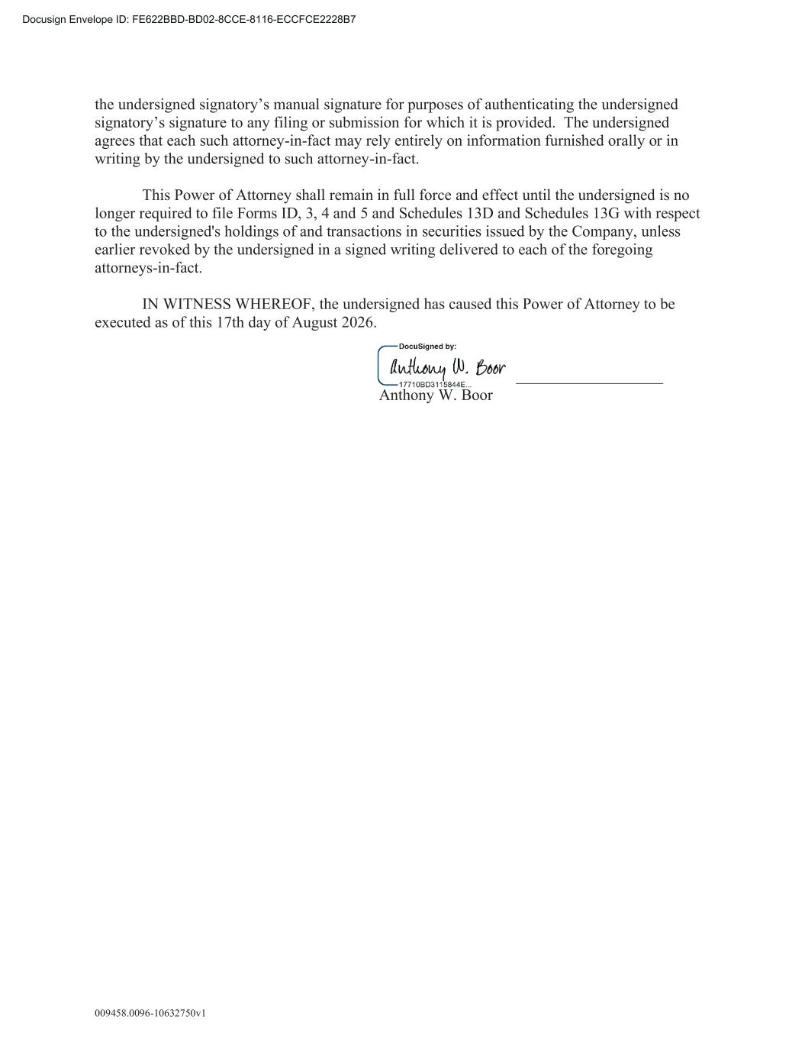
009458.0096-10632750v1 the undersigned signatory’s manual signature for purposes of authenticating the undersigned signatory’s signature to any filing or submission for which it is provided. The undersigned agrees that each such attorney-in-fact may rely entirely on information furnished orally or in writing by the undersigned to such attorney-in-fact. This Power of Attorney shall remain in full force and effect until the undersigned is no longer required to file Forms ID, 3, 4 and 5 and Schedules 13D and Schedules 13G with respect to the undersigned's holdings of and transactions in securities issued by the Company, unless earlier revoked by the undersigned in a signed writing delivered to each of the foregoing attorneys-in-fact. IN WITNESS WHEREOF, the undersigned has caused this Power of Attorney to be executed as of this 17th day of August 2026. Anthony W. Boor

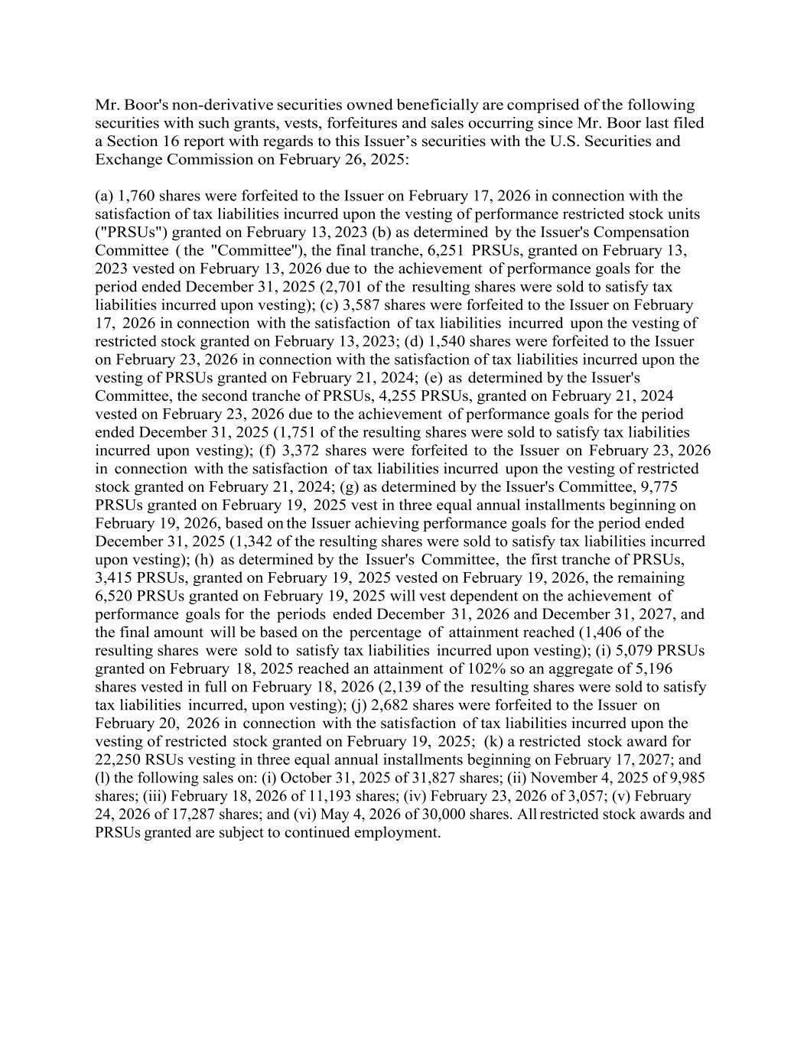
Mr. Boor's non-derivative securities owned beneficially are comprised of the following securities with such grants, vests, forfeitures and sales occurring since Mr. Boor last filed a Section 16 report with regards to this Issuer’s securities with the U.S. Securities and Exchange Commission on February 26, 2025: (a) 1,760 shares were forfeited to the Issuer on February 17, 2026 in connection with the satisfaction of tax liabilities incurred upon the vesting of performance restricted stock units ("PRSUs") granted on February 13, 2023 (b) as determined by the Issuer's Compensation Committee ( the "Committee''), the final tranche, 6,251 PRSUs, granted on February 13, 2023 vested on February 13, 2026 due to the achievement of performance goals for the period ended December 31, 2025 (2,701 of the resulting shares were sold to satisfy tax liabilities incurred upon vesting); (c) 3,587 shares were forfeited to the Issuer on February 17, 2026 in connection with the satisfaction of tax liabilities incurred upon the vesting of restricted stock granted on February 13, 2023; (d) 1,540 shares were forfeited to the Issuer on February 23, 2026 in connection with the satisfaction of tax liabilities incurred upon the vesting of PRSUs granted on February 21, 2024; (e) as determined by the Issuer's Committee, the second tranche of PRSUs, 4,255 PRSUs, granted on February 21, 2024 vested on February 23, 2026 due to the achievement of performance goals for the period ended December 31, 2025 (1,751 of the resulting shares were sold to satisfy tax liabilities incurred upon vesting); (f) 3,372 shares were forfeited to the Issuer on February 23, 2026 in connection with the satisfaction of tax liabilities incurred upon the vesting of restricted stock granted on February 21, 2024; (g) as determined by the Issuer's Committee, 9,775 PRSUs granted on February 19, 2025 vest in three equal annual installments beginning on February 19, 2026, based on the Issuer achieving performance goals for the period ended December 31, 2025 (1,342 of the resulting shares were sold to satisfy tax liabilities incurred upon vesting); (h) as determined by the Issuer's Committee, the first tranche of PRSUs, 3,415 PRSUs, granted on February 19, 2025 vested on February 19, 2026, the remaining 6,520 PRSUs granted on February 19, 2025 will vest dependent on the achievement of performance goals for the periods ended December 31, 2026 and December 31, 2027, and the final amount will be based on the percentage of attainment reached (1,406 of the resulting shares were sold to satisfy tax liabilities incurred upon vesting); (i) 5,079 PRSUs granted on February 18, 2025 reached an attainment of 102% so an aggregate of 5,196 shares vested in full on February 18, 2026 (2,139 of the resulting shares were sold to satisfy tax liabilities incurred, upon vesting); (j) 2,682 shares were forfeited to the Issuer on February 20, 2026 in connection with the satisfaction of tax liabilities incurred upon the vesting of restricted stock granted on February 19, 2025; (k) a restricted stock award for 22,250 RSUs vesting in three equal annual installments beginning on February 17, 2027; and (l) the following sales on: (i) October 31, 2025 of 31,827 shares; (ii) November 4, 2025 of 9,985 shares; (iii) February 18, 2026 of 11,193 shares; (iv) February 23, 2026 of 3,057; (v) February 24, 2026 of 17,287 shares; and (vi) May 4, 2026 of 30,000 shares. All restricted stock awards and PRSUs granted are subject to continued employment.

